Hemagglutination Images For Practice:

Question 1:
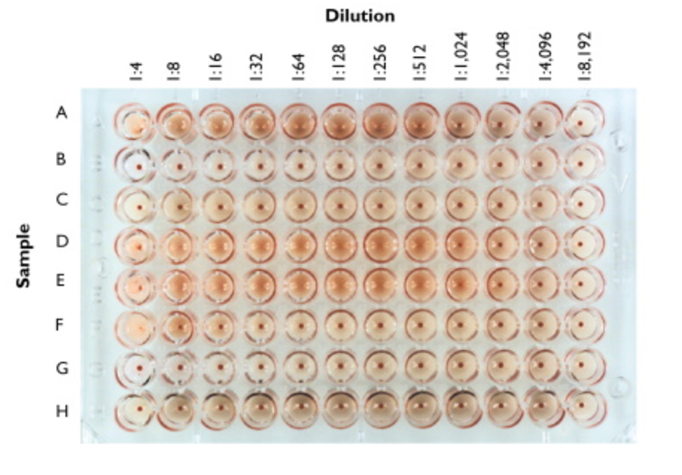
For the image above, each row (A-H) shows how one would determine the titer for antigens A, B, C, etc… NOTE: some antigens may not have enough dilutions to find the correct titer, so mark NA (not available) for those. Write down the titer for each of the rows here: (answers at end of page)

A - __1024________ E - __512________

B - __N/A_______ F - ____4______

C - ___N/A_______ G - ___N/A_______

D - ___512_______ H - ____N/A______

QUESTION 2:

The figure legend for the hemagglutination assay shown below is presented for you here.

Figure 4. Hemagglutination assay for influenza virus. Patients had blood drawn and their blood was centrifuged to remove cells. Two-fold dilutions of the serum were added to some sheep red blood cells and incubated at 37˚C. After an hour, the plate was removed from the incubator and scored for the titers of each.

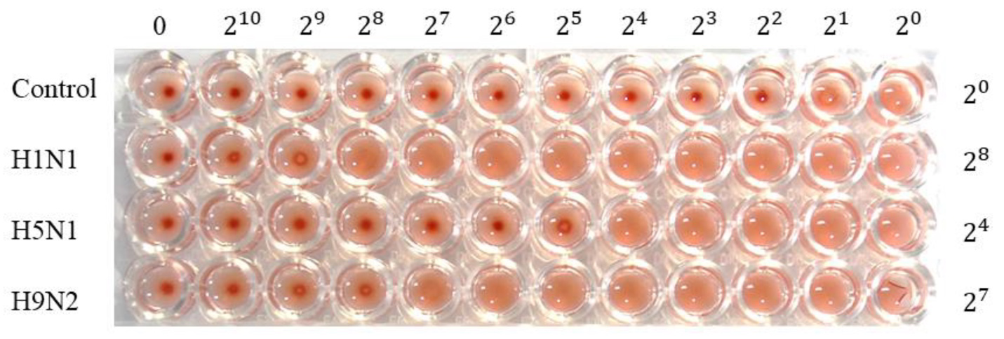

For this image:
- What does the control represent? Is it a positive or negative control? What is happening in wells 2¹ and 2⁰ in the control lane? The control represents the wells containing a sample of the item to be tested to be used to observe the clumping or the red blood cells in absence of the virus. This is a negative control. In 21 and 20 there is a high concentration of the virus in the wells.
- What does it mean to see a tight pellet of RBC on the bottom of the well in this particular case? The observed tight pellet of the RBC is the clumping of red blood cells which shows the absence of the virus.
- What is the difference between the 0 and the 2⁰ wells?in wells 0, the RBC clumping dominates showing the absence of the virus while in wells 20 suspensions are observed, hence the high concentration of the Virus.
- What is the Titer for the H1N1 ____256_____? H5N1 ___16 _______? H9N2 ___128_______?
(report these as a whole number, not an exponent)

Question 3

In the images below, a hemagglutination assay was performed. From the image in A, you should be able to figure out what the titer was for each row. For this experiment, they report the titer based on the number of the column where the last activity is observed

For example.
The WT row represents a positive control. This means we look for the last place we can see the activity of this control and the activity being measured is hemagglutination (based on the HA titer (log₂)). I see that in well 7, more cells are pelleted than in lane 6 in the WT row. This tells me the last place where activity was observed was in lane 6. When I look at figure B, it shows a HA titer of ≈5.8 with the little line on top of the black rectangle representing variations above the mean in multiple control experiments with WT.

So before looking at panel B, YOU determine the titers for each row, then compare your answers with what you see in Panel B.
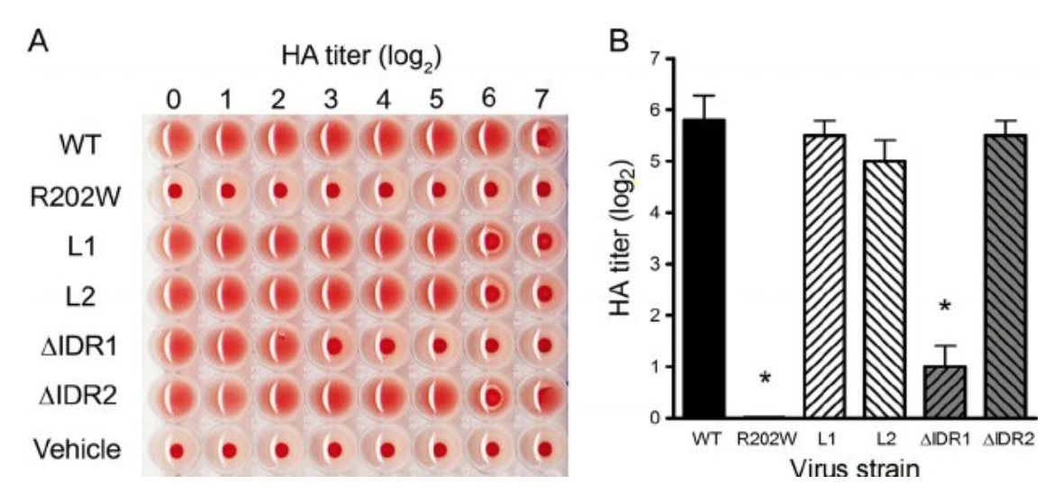

- What are the titers for:
  - WT ___6___6_____
  - R202W ___0_______
  - L1 _____5_________
  - L2 ______5________
  - dIDR1 ____2_______
  - DIDR2 _____5______
  - Vehicle _____0____

- How good were your answers compared to the titers reported in panel B?
  - WT ___close to 5.8 mean_____6_____
  - R202W ___0 close to mean 0_______
  - L1 __5 not close to mean __5.5__________
  - L2 _5 close to mean _____5_______
  - dIDR1 _2 not close to mean ____1______
  - DIDR2 ____5 not close to mean ___5.5____
  - Vehicle ___0 mean ___N/A.___

- What does Vehicle represent? The vehicle represents the solvent used to enable quick detection of agglutination.

